Q1.
Figure 1 shows a static electricity generator.
Figure 1
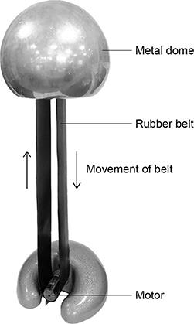
The rubber belt is turned by a motor.
As the rubber belt moves, charge is transferred from the rubber belt to the metal dome.
Figure 2 shows a student touching the metal dome of the static electricity generator.
The dome is negatively charged.
Figure 2
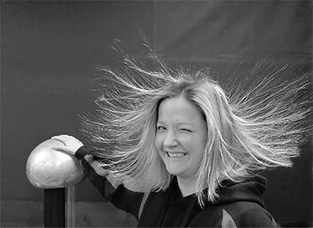
(a) Complete the sentence.
Choose the answer from the box.

negative | neutral | positive

When the student touches the negatively charged metal dome the student s hair
gains a ______________________________ charge.
(1)
(b) Complete the sentence.
Choose the answer from the box.

attraction | gravity | repulsion

The hair on the student s head stands up because the strands of hair experience
forces of ______________________________ .
(1)
(c) Which of the following diagrams shows the electric field pattern around the negatively charged metal dome?
Tick (✓) one box.
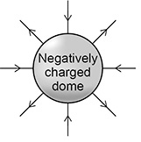 | 
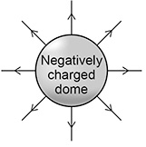
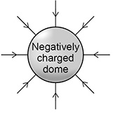
(1)
Figure 3 shows the negatively charged metal dome and an earthed conductor.
Figure 3
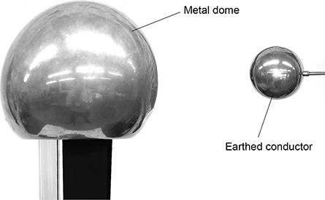
(d) The air between the dome and the earthed conductor is an insulator.
Complete the sentence.
Choose the answer from the box.

efficiency | resistance | temperature

The air between the dome and the earthed conductor has
a high ______________________________.
(1)
The earthed conductor is moved closer to the metal dome.
A spark jumps from the dome to the earthed conductor.
(e) Complete the sentence.
Choose the answer from the box.

earthed | ionised | neutral

The spark jumps because the air around the charged dome has
become ______________________________.
(1)
(f) Which particles are transferred when the spark jumps from the negatively charged metal dome to the earthed conductor?
Tick (✓) one box.

Electrons
Neutrons
Protons
(1)
(g) The potential difference between the metal dome and earth is 300 000 V.
When the spark jumps there is a charge flow of 0.000 002 C.
Calculate the energy transferred by the spark.
Use the equation:
energy transferred = charge flow × potential difference
___________________________________________________________________
___________________________________________________________________
___________________________________________________________________
Energy transferred = ____________________ J
(2)
(Total 8 marks)
Q2.
(a) A student uses some everyday items to investigate static electricity.

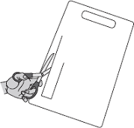 | 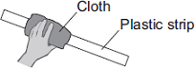 | 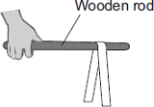
1 A strip of plastic is cut from a plastic carrier bag | 2 The plastic strip is rubbed with a cloth | 3 The plastic strip is hung over a wooden rod
(i) Draw a ring around the correct answer in the box to complete each sentence.
Rubbing the plastic strip with a cloth causes the strip to become negatively charged.

 | electrons
This happens because | neutrons | move from the cloth onto the plastic strip.
 | protons

 | a negative
The cloth is left with | a positive | charge.
 | zero
(2)
(ii) When the plastic strip is hung over the wooden rod, the two halves of the strip move equally away from each other.
What two conclusions should the student make about the forces acting on the two halves of the plastic strip?
1. ____________________________________________________________
______________________________________________________________
2. ____________________________________________________________
______________________________________________________________
(2)
(b) Electrical charges move more easily through some materials than through other materials.
Through which one of the following materials would an electrical charge move most easily?
Draw a ring around your answer.

aluminium | glass | rubber
(1)
(Total 5 marks)
Q3.
A student used some everyday items to investigate static electricity.
Figure 1 shows a flexible plastic strip being rubbed with a cloth.
Figure 1
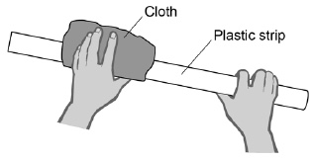
(a) Complete the sentence.
Choose the answer from the box.

electrons | neutrons | protons
Rubbing the plastic strip with the cloth causes the strip to become
negatively charged because ____________________ move from the cloth
onto the plastic strip.
(1)
(b) Complete the sentence.
Choose the answer from the box.

a negative | a positive | zero
The cloth is left with ____________________ charge.
(1)
(c) The student hung the plastic strip over a wooden rod.
The ends of the strip moved away from each other.
Figure 2 shows the position of the plastic strip on the wooden rod.
Figure 2
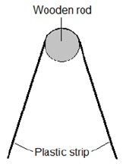
What two conclusions should the student make about the forces acting on the two halves of the plastic strip?
1. _________________________________________________________________
___________________________________________________________________
2. _________________________________________________________________
___________________________________________________________________
(2)
(d) Another student repeated the experiment using the same method and found the plastic strip moved in the same way.
Complete the sentence.
Choose the answer from the box.

an anomaly | repeatable | reproducible
The investigation was _____________________ .
(1)
(Total 5 marks)
Q4.
(a) The diagram shows a negatively charged plastic rod held near to a thin stream of water. The water is attracted towards the rod.
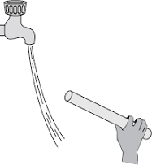
Which one of the following statements explains what is happening to the charge in the water?
Tick ( ) one box.

The positive and the negative charges in the water are attracted to the rod. | 
The positive and the negative charges in the water are repelled by the rod.
The negative charge in the water is repelled by the rod and the positive charge is attracted to the rod.
The negative charge in the water is attracted to the rod and the positive charge is repelled by the rod.
(1)
(b) A company that produces bottles of mouthwash found a problem with the automatic filling system.
As the bottles go towards the filler, the bottles move around on the conveyor belt and become electrostatically charged. This causes the stream of mouthwash to move sideways, missing the open top of the bottle.
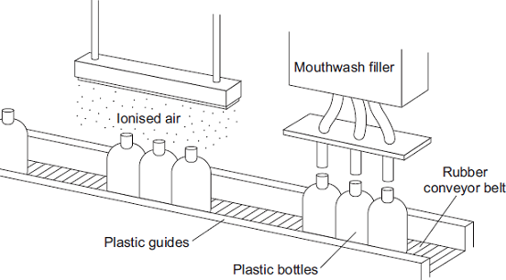
The company came up with an answer to the problem. Before the bottles reach the dfiller, the bottles pass through a stream of ionised air. The ions in the air neutralise the charge on the bottles.
(i) Explain why the plastic bottles became charged.
______________________________________________________________
______________________________________________________________
______________________________________________________________
______________________________________________________________
(2)
(ii) What happens to the structure of an atom to change the atom into an ion?
______________________________________________________________
______________________________________________________________
(1)
(iii) Earthing the conveyor belt with a conducting wire would not have solved this problem.
Give a reason why.
______________________________________________________________
______________________________________________________________
(1)
(Total 5 marks)
Q5.
(a) The diagram shows a polythene rod being rubbed with a woollen cloth.
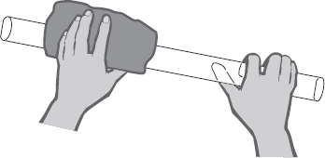
The polythene rod becomes negatively charged.
Explain how this happens.
___________________________________________________________________
___________________________________________________________________
___________________________________________________________________
___________________________________________________________________
(2)
(b) A student put the charged polythene rod on to a balance. The rod was separated from the metal pan of the balance by a thin block of insulating material.
The student then held a second charged polythene rod above, but not touching, the first rod. The reading on the balance increased.

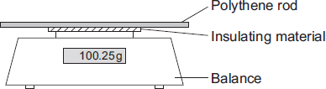
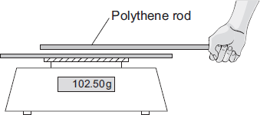
(i) Explain why the reading on the balance increases.
______________________________________________________________
______________________________________________________________
______________________________________________________________
______________________________________________________________
(2)
(ii) The student observed that the nearer the two rods are to each other, the bigger the increase in the balance reading.
What should the student conclude from this observation?
______________________________________________________________
______________________________________________________________
______________________________________________________________
______________________________________________________________
(2)
(Total 6 marks)
Q6.
During car journeys, the driver will often become electrostatically charged.
This is more noticeable on dry days than on damp, humid days.
(a) Explain what happens to cause the driver to become charged.
___________________________________________________________________
___________________________________________________________________
___________________________________________________________________
___________________________________________________________________
(2)
(b) Scientists were asked to find out whether the build-up of charge on the driver depends on the type of material used to make the driver’s clothes. The results of the investigation are given in the table.

Material | Humidity | Temperature in °C | Charge on the driver  in millicoulombs
Nylon | 48% | 18 | 3.0 to 3.2
Wool | 48% | 18 | 2.4 to 2.5
Cotton | 48% | 18 | 1.4 to 1.7
Humidity is a measure of how much water vapour the air can hold.
(i) Why was it important that the scientists controlled the humidity?
______________________________________________________________
______________________________________________________________
(1)
(ii) Does the data in the table show that the charge on the driver would always be less if they were to wear cotton clothing?
Give a reason for your answer.
______________________________________________________________
______________________________________________________________
(1)
(Total 4 marks)

Q7.
Figure 1 shows a student walking on a carpet.
Figure 1
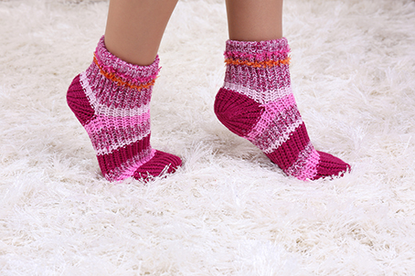
(a) The student becomes negatively charged because of the friction between her socks and the carpet.
Explain why the friction causes the student to become charged.
___________________________________________________________________
___________________________________________________________________
___________________________________________________________________
___________________________________________________________________
(2)
(b) The student’s head is represented by the sphere in Figure 2.
The student is negatively charged. The arrow shows part of the electric field around the student’s head.
Draw three more arrows on Figure 2 to complete the electric field pattern.
Figure 2
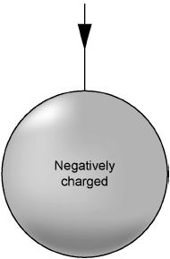
(1)
(c) The negatively charged student touches a metal tap and receives an electric shock.
Explain why.
___________________________________________________________________
___________________________________________________________________
___________________________________________________________________
___________________________________________________________________
___________________________________________________________________
___________________________________________________________________
(3)
(d) Some carpets have thin copper wires running through them. The student is less likely to receive an electric shock after walking on this type of carpet.
Suggest why.
___________________________________________________________________
___________________________________________________________________
___________________________________________________________________
___________________________________________________________________
___________________________________________________________________
___________________________________________________________________
(2)
(Total 8 marks)
Q8.
Figure 1 shows a static electricity generator.
Figure 1
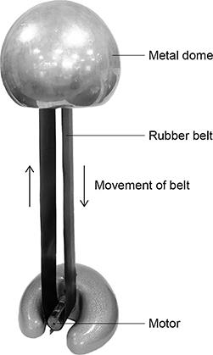
The rubber belt is turned by a motor.
As the rubber belt moves, charge is transferred from the rubber belt to the metal dome.
(a) Figure 2 shows a student touching the metal dome of the static electricity generator.
The dome is negatively charged.
Figure 2
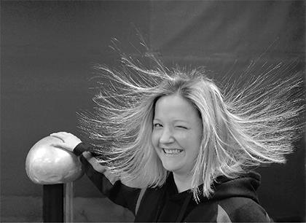
Explain why the student s hair stands up on end.
___________________________________________________________________
___________________________________________________________________
___________________________________________________________________
___________________________________________________________________
___________________________________________________________________
___________________________________________________________________
(3)
The charged metal dome creates an electric field.
(b) What is an electric field?
___________________________________________________________________
___________________________________________________________________
___________________________________________________________________
(1)
(c) How does the electric field strength vary as the distance from the charged metal dome increases?
___________________________________________________________________
___________________________________________________________________
(1)
Figure 3 shows the negatively charged metal dome and an earthed conductor.
Figure 3
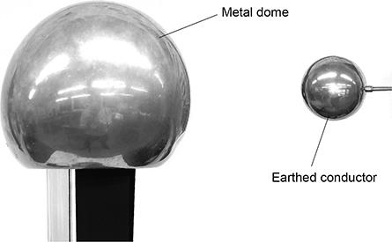
When the earthed conductor is moved towards the metal dome, there is a spark between the dome and the earthed conductor.
(d) The spark transfers 0.60 J of energy, and 2.0 μC of charge is transferred from the dome to the earthed conductor.
Calculate the potential difference between the metal dome and the earthed conductor.
Use the Physics Equations Sheet.
___________________________________________________________________
___________________________________________________________________
___________________________________________________________________
___________________________________________________________________
___________________________________________________________________
___________________________________________________________________
___________________________________________________________________
Potential difference = ____________________ V
(4)
(e) Which of the following changes would increase the distance a spark can jump between the dome and the earthed conductor?
Tick (✓) one box.

Decreased charge on the metal dome
Decreased electric field strength
Decreased electrical resistance of air
Decreased potential difference
(1)
(Total 10 marks)
Q9.
Figure 1 shows a Van de Graaff generator that is used to investigate static electricity.
Before it is switched on, the metal dome has no net charge.
After it is switched on, the metal dome becomes positively charged.
Figure 1
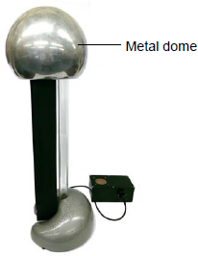
© Michael Priest
(a) Explain how an uncharged object may become positively charged.
___________________________________________________________________
___________________________________________________________________
___________________________________________________________________
___________________________________________________________________
___________________________________________________________________
___________________________________________________________________
(3)
(b) Figure 2 shows a plan view of the positively charged metal dome of a Van de Graaff generator.
Draw the electric field pattern around the metal dome when it is isolated from its surroundings.
Use arrows to show the direction of the electric field.
Figure 2
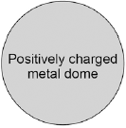
(2)
(c) Another positively charged object is placed in the electric field.
Look at Figure 3.
Figure 3
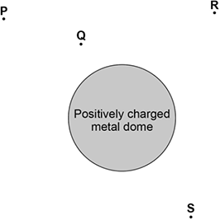
In which position would the object experience the greatest force?

Tick one box.
P | 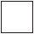
Q
R
S
(1)
(Total 6 marks)

Mark schemes
Q1.
(a) negative
1
(b) repulsion
1
(c)
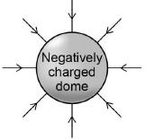
1
(d) resistance
1
(e) ionised
1
(f) electrons
1
(g) energy transferred = 0.000 002 × 300 000
1
energy transferred = 0.6 (J)
1
[8]
Q2.
(a) (i) electrons
1
a positive
1
(ii) (forces are) equal
accept (forces are)the same
forces are balanced is insufficient
1
(forces act in) opposite directions
accept (forces) repel
both sides have the same charge is insufficient
1
(b) aluminium
1
[5]
Q3.
(a) electrons
1
(b) a positive
1
(c) the forces are repulsive
allow the forces act in opposite directions
1
the forces are equal in size
allow the forces are the same (size)
1
(d) reproducible
1
[5]
Q4.
(a) 3rd box
The negative charge in the water is repelled by the rod and the positive charge
is attracted to the rod.
1
(b) (i) friction between bottles and conveyor belt / (plastic) guides
accept bottles rub against conveyor belt / (plastic) guides
1
charge transfers between bottles and conveyor belt / (plastic) guides
accept specific reference eg electrons move onto / off the bottles
reference to positive electrons / protons negates this mark
1
(ii) (the atom) loses or gains one (or more) electrons
1
(iii) charge will not (easily) flow off the conveyor belt / bottles
accept the conveyor belt / bottles is an insulator / not a conductor accept conveyor belt is rubber
1
[5]
Q5.
(a) electrons transfer / removed
do not accept negatively charged atoms for electrons
this only scores if first mark given
1
to the rod / from the cloth
this does not score if there is reference to any original charge on cloth or rod
‘it’ refers to the rod
accept negative charge transfer to rod / removed from cloth for 1 mark
transfer of positive charge / positive electrons scores zero
1
(b) (i) rods / charges repel
1
creating downward / extra force (on the balance)
accept pushing (bottom) rod downwards
do not accept increasing the weight / mass
charges attracting scores zero
1
(ii) the (repulsion) force increases as the distance between the charges
decreases
accept there is a negative correlation between (repulsion) force and distance between charges
or
(repulsion) force and distance between charges are inversely proportional
for both marks
examples of 1 mark answers
force increases as distance decreases
force and distance are inversely proportional
negative correlation between force and distance
repels more as distance decreases
if given in terms of attracting or attraction force this mark does not score
2
[6]
Q6.
(a) clothing and seat rub together
accept friction between clothing and seat
1
electrons transfer from seat to driver
or
electrons transfer from driver to seat
accept electrons transfer on its own if first mark scores
an answer in terms of rubbing, between clothing and seat and charge transfer without mention of electrons gains 1 mark
an answer in terms of friction / rubbing and electron transfer without mention of clothing and seat gains 1 mark
1
(b) (i) how wet the air is affects charge (build up)
accept humidity affects charge
or
damp air is a better conductor
or
damp air has a lower resistance
do not accept fair test or as a control unless explained
1
(ii) No – it was only the lowest under these conditions
accept answer in terms of changing the conditions may change the results
or
No – there are lots of other materials that were not tested
or
Yes – the highest value for cotton is smaller than the lowest value for
the other materials
do not accept results show that it is always less / smallest
1
[4]
Q7.
(a) transfer of electrons
mention of positive charge moving negates both marks
1
from the carpet to the student
1
(b) three arrows perpendicular to sphere’s surface with all arrows directed inwards and distributed evenly around sphere
1
(c) there is a potential difference between the student and the tap
do not accept the tap / sink is charged
1
which causes electrons / charges to transfer from the student
or
which causes electrons / charges to transfer to the tap
1
which earths the charge
allow the tap is earthed
1
(d) carpet / copper has a low resistance
allow carpet is a conductor
or
copper is a conductor
1
lower / no build-up of charge (on the student)
or
(so there is a) smaller / no potential difference between student and tap / earth
1
[8]
Q8.
(a) electrons are transferred to the student
1
(so) her hair is negatively charged
allow each hair has the same (negative) charge
1
(and) like charges repel
do not accept student being positively charged for MP1 and MP2
1
(b) the region (around a charged object) where another charged object experiences a force
allow space / area for region
allow particle for object
1
(c) (electric field strength) decreases
1
(d) Q = 2 × 10^{–6} (C)
1
0.6 = 2 × 10^{–6} × V
allow a correct substitution of an incorrectly / not converted value of Q
1
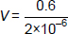
allow a correct rearrangement of an incorrectly / not converted value of Q
1
V = 300 000 (V)
allow an answer consistent with an incorrectly / not converted value of Q
1
(e) decreased electrical resistance of air
1
[10]
Q9.
(a) negatively charged
1
electrons are transferred
1
from the (neutral) object
1
(b) minimum of four lines drawn perpendicular to surface of sphere
judge by eye
1
minimum of one arrow shown pointing away from sphere
do not accept any arrow pointing inwards.
1
(c) Q
1
[6]

